24.23:
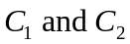 are in parallel, so 